Example One
PHRASE | NP |  |  | VP
Word | Some | cruel | teachers | grade | mercilessly
Part of Speech | Det | Adj | N | V | Adv

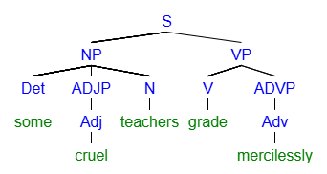

[S [NP [Det some] [ADJP [Adj cruel]] [N teachers]] [VP [V grade] [ADVP [Adv mercilessly]

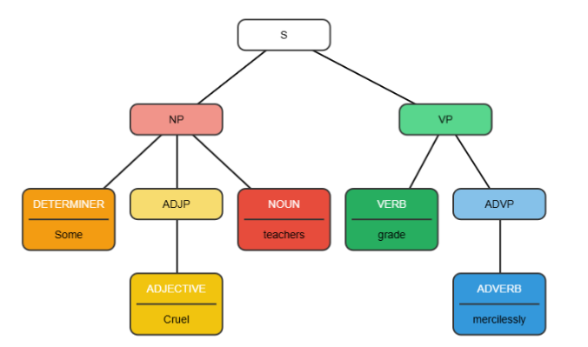
Practice Two
PHRASE | N | ADVP | V | ADVP | PP
Word | Carlie | usually | parties | recklessly | on | Fridays
Part of Speech | N | Adv | V | Adv | Prep | N

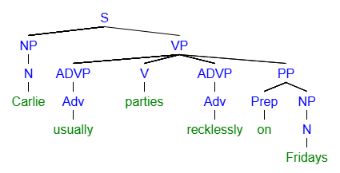

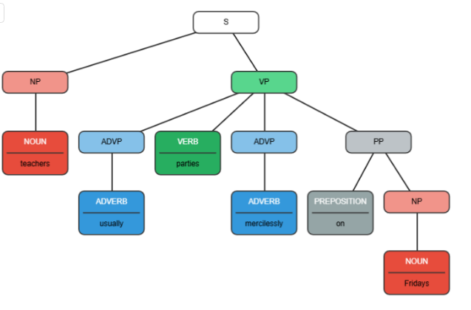

Practice One
PHRASE | NP | VP |  | PP
Word | Guests | often | leave | without | a | kind | single | word
Part of Speech | N | Adv | V | Prep | Det |  |  | N

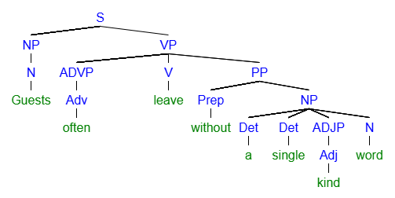
[S [NP [N Guests]] [VP [ADVP [Adv often]] [V leave] [PP [Prep without] [NP [Det a] [Det single] [ADJP [Adj kind]] [N word]
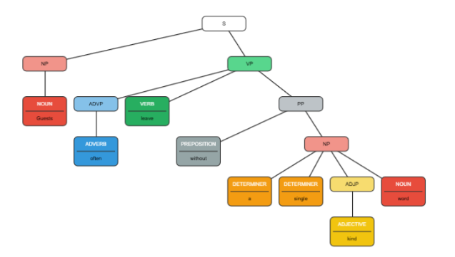

Practice Three
PHRASE | NP |  |  | VP | PP
Word | His | little | sister | roots | for | the | Broncos
Part of Speech | Det | Adj | N | V | Prep | Det | N

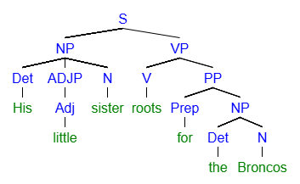
[S [NP [Det His] [ADJP [Adj little]] [N sister]] [VP [V roots] [PP [Prep for] [NP [Det the] [N Broncos]

Practice Four
PHRASE | NP |  |  |  | VP |  | PP
Word | Some | very | contentious | debates | calm | noticeably | after | lunch
Part of Speech | Det | Adv | Adj | N | V | Adv | Prep | N

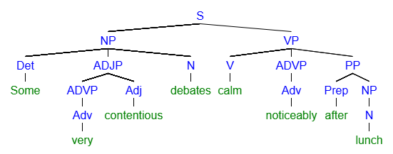
[S [NP [Det Some] [ADJP [ADVP [Adv very]] [Adj contentious]] [N debates]] [VP [V calm] [ADVP [Adv noticeably]] [PP [Prep after] [NP [N lunch]
Example Five
PHRASE | NP |  |  |  |  |  | VP
Word | All | the | old | books | in | Libraries | beckon | silently
Part of Speech | Det | Det | Adj | N | Prep | N | V | Adv

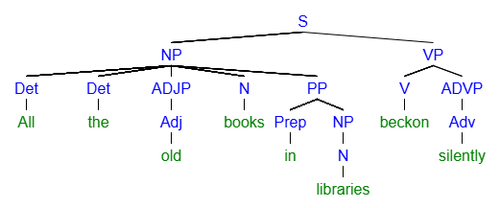
[S [NP [Det All] [Det the] [ADJP [Adj old]] [N books] [PP [Prep in] [NP [Det the] [N library]]]] [VP [V beckon] [ADVP [Adv silently]]

